Architectural Components - Repository

📝Definition
# Source: AI Source: Provided by: [Data Path: Persons Table -> ID Column: 1, Name_En Column: Motasem Essam] -> From: [ChatGPT] on [1/23/2026]
The Repository is a component responsible for data access and persistence. It acts as a bridge between the domain (Model/Service) and the data source (database, API, file system).
👉 The Repository hides how data is stored or retrieved and provides a clean interface to the rest of the application.

🔑 Responsibilities of Repository
# Source: AI Source: Provided by: [Data Path: Persons Table -> ID Column: 1, Name_En Column: Motasem Essam] -> From: [ChatGPT] on [1/23/2026]
- Retrieve and store data
- Abstract database or external API logic
- Provide a clean interface for data operations
- Keep business logic separate from data access

🧱 Example
# Source: AI Source: Provided by: [Data Path: Persons Table -> ID Column: 1, Name_En Column: Motasem Essam] -> From: [ChatGPT] on [1/23/2026]
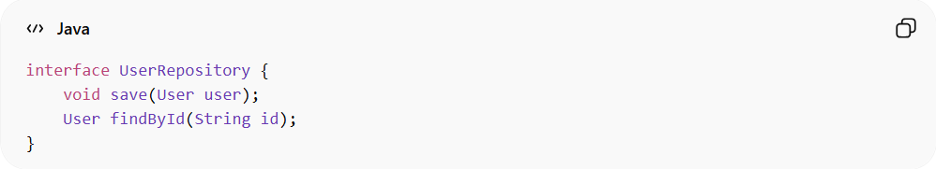
interface UserRepository {
void save(User user);
User findById(String id);
}
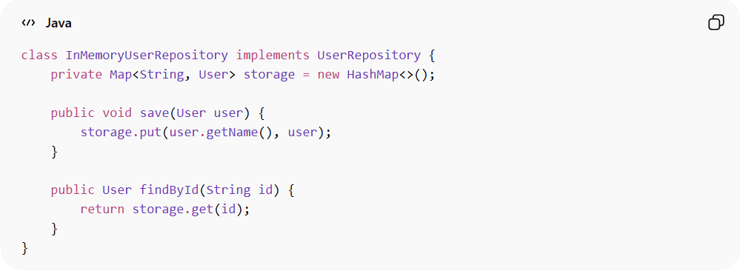
class InMemoryUserRepository implements UserRepository {
private Map<String, User> storage = new HashMap<>();

public void save(User user) {
storage.put(user.getName(), user);
}

public User findById(String id) {
return storage.get(id);
}
}
👉 Here:
- UserRepository defines what operations are available
- InMemoryUserRepository defines how data is stored

❌ Bad Example (No Repository)
# Source: AI Source: Provided by: [Data Path: Persons Table -> ID Column: 1, Name_En Column: Motasem Essam] -> From: [ChatGPT] on [1/23/2026]
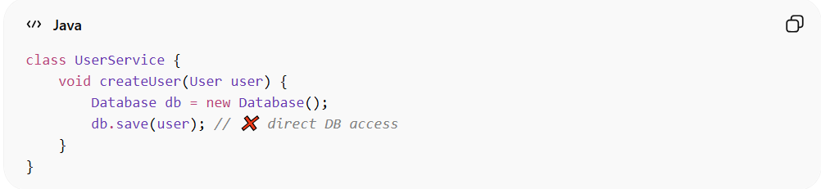
class UserService {
void createUser(User user) {
Database db = new Database();
db.save(user); // ❌ direct DB access
}
}
👉 Problems:
- Tight coupling with database
- Hard to test or replace data source
- Violates separation of concerns

✅ Good Example (Using Repository)
# Source: AI Source: Provided by: [Data Path: Persons Table -> ID Column: 1, Name_En Column: Motasem Essam] -> From: [ChatGPT] on [1/23/2026]
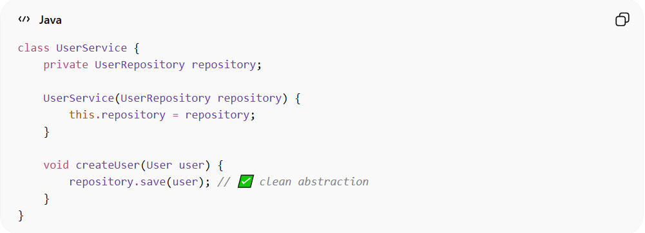
class UserService {
private UserRepository repository;

UserService(UserRepository repository) {
this.repository = repository;
}

void createUser(User user) {
repository.save(user); // ✅ clean abstraction
}
}
👉 Benefits:
- Decoupled from database implementation
- Easy to mock in tests
- Flexible to switch DB/API

🔄 Repository in Different Patterns
# Source: AI Source: Provided by: [Data Path: Persons Table -> ID Column: 1, Name_En Column: Motasem Essam] -> From: [ChatGPT] on [1/23/2026]
- MVC / MVVM → Used by Service or ViewModel
- DDD → Repository manages Aggregates
- Clean Architecture → Part of the data layer

⚠️ Common Mistakes
# Source: AI Source: Provided by: [Data Path: Persons Table -> ID Column: 1, Name_En Column: Motasem Essam] -> From: [ChatGPT] on [1/23/2026]
- Putting business logic inside Repository ❌
- Exposing database-specific code (SQL, ORM details) ❌
- Not using interfaces (hard to test/mock) ❌

💡 Key Idea
# Source: AI Source: Provided by: [Data Path: Persons Table -> ID Column: 1, Name_En Column: Motasem Essam] -> From: [ChatGPT] on [1/23/2026]
Repository is not the database — it’s the interface to access data

🧾 Summary
# Source: AI Source: Provided by: [Data Path: Persons Table -> ID Column: 1, Name_En Column: Motasem Essam] -> From: [ChatGPT] on [1/23/2026]
Repository:
- Handles data access
- Hides implementation details
- Improves testability and flexibility
- Keeps business logic clean

